40. Parent to Child Traverse and SELF Traverse - 27 May 2022



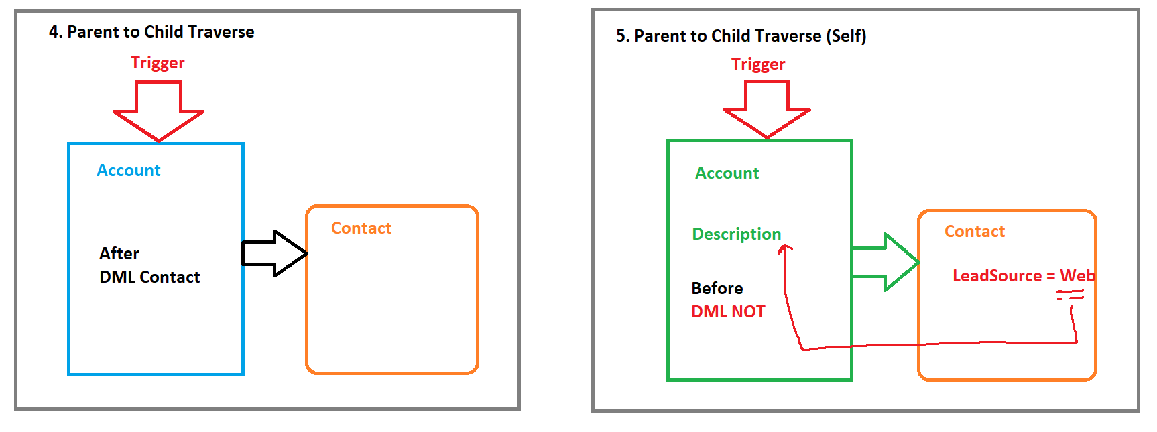

**STEPS:**

1] Parent Map<ID,Parent>

2] List<Child> 🡪 SOQL Over Child where Parent ID IN : Map.keySet()

3] Iterate Over Child List 🡪 Check contains Key in Map 🡪 Apply Appropriate Logic

User Story 1] When Account’s Type is “Technology Partner”, then update all the Contact’s LeadSource as “Web” and Level should be “Primary”. Else none.

|  |  |
| --- | --- |
| Event | After |
| Operations | Update |
| Trigger Object | Account |
| Affecting Object | Contact |

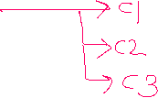

trigger AccountTrigger27May on Account (after update) {

Map<Id,Account> accMap = new Map<Id,Account>();

for(Account objAcc : trigger.new){

if(objAcc.Type != trigger.oldMap.get(objAcc.Id).Type)

accMap.put(objAcc.Id, objAcc);

}

List<Contact> conList = new List<Contact>();

if(!accMap.isEmpty()){

for(Contact objCon : [select Id,LeadSource, Level__c,AccountId from Contact where AccountId IN : accMap.keySet()]){

conList.add(objCon);

}

}

if(!conList.isEmpty()){

for(Contact objCon : conList){

if(accMap.containsKey(objCon.AccountId)){

if(accMap.get(objCon.AccountId).Type =='Technology Partner'){

objCon.LeadSource = 'Web';

objCon.Level__c = 'Primary';

}

else{

objCon.LeadSource = '';

objCon.Level__c = '';

}

}

}

Database.update(conList,false);

}

}

User Story 2]

If Applicant is eligible for Police Verification and Male , then update All the addresses city as “Nagpur” only if the Address Pin Code starts with “44”.

trigger ApplicantTrigger27May on Applicant__c (after update) {

Map<Id,Applicant__c> appMap = new Map<Id,Applicant__c>();

for(Applicant__c objApp : trigger.new){

if( (objApp.Police_Verification__c != trigger.oldMap.get(objApp.Id).Police_Verification__c) || (objApp.Gender__c != trigger.oldMap.get(objApp.Id).Gender__c)){

appMap.put(objApp.Id, objApp);

}

}

List<Address__c> adrList = new List<Address__c>();

if(!appMap.isEmpty()){

for(Address__c objAdr : [select Id, Pin_Code__c, City__c,Applicant__c,State__c,Country__c from Address__c where Applicant__c IN : appMap.keySet()]){

adrList.add(objAdr);

}

}

if(!adrList.isEmpty()){

for(Address__c objAdr : adrList){

if(appMap.containsKey(objAdr.Applicant__c)){

if(appMap.get(objAdr.Applicant__c).Police_Verification__c && appMap.get(objAdr.Applicant__c).Gender__c =='Male'){

if(objAdr.Pin_Code__c.startsWith('44')){

objAdr.Country__c ='India';

objAdr.State__c ='Maharashtra';

objAdr.City__c ='Nagpur';

}

else{

objAdr.Country__c ='';

objAdr.State__c ='';

objAdr.City__c ='';

}

}

else{

objAdr.Country__c ='';

objAdr.State__c ='';

objAdr.City__c ='';

}

}

}

Database.update(adrList,false);

}

}

If Account Type is set to the “Prospect”, and If Account’s Opp Amount is less than 10000, then copy its Opp Name in ACCOUNT’S Description.

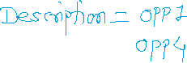

|  |  |
| --- | --- |
| Event | Before |
| Operations | Update |
| Trigger Object | Account |
| Affecting Object | Account (DML NO) |

trigger AccountTrigger27May on Account (before update) {

Map<Id,Account> accMap = new Map<Id,Account>();

for(Account objAccount : trigger.new){

if(objAccount.Type != trigger.oldMap.get(objAccount.id).Type)

accMap.put(objAccount.Id, objAccount);

}

List<Opportunity> oppList = new List<Opportunity>();

if(!accMap.isEmpty()){

for(Opportunity objOpp: [select Id, Amount, Name, AccountId from Opportunity where AccountId IN : accMap.keySet()]){

oppList.add(objOpp);

}

}

if(!oppList.isEmpty()){

for(Opportunity objOpp : oppList){

if(accMap.containsKey(objOpp.AccountId)){

if(accMap.get(objOpp.AccountId).Type == 'Prospect'){

if(objOpp.Amount < 10000){

if(accMap.get(objOpp.AccountId).Description==null){

accMap.get(objOpp.AccountId).Description = objOpp.Name;

}

else{

accMap.get(objOpp.AccountId).Description = accMap.get(objOpp.AccountId).Description +'\n'+objOpp.Name;

}

}

}

else{

accMap.get(objOpp.AccountId).Description = '';

}

}

}

}

}